**EXPERIMENT 7**

**DQL COMMANDS (COLLEGE SCHEMA)**

**Aim:**

* Display student id and marks from the student table.

**select student_id,marks from student_;**

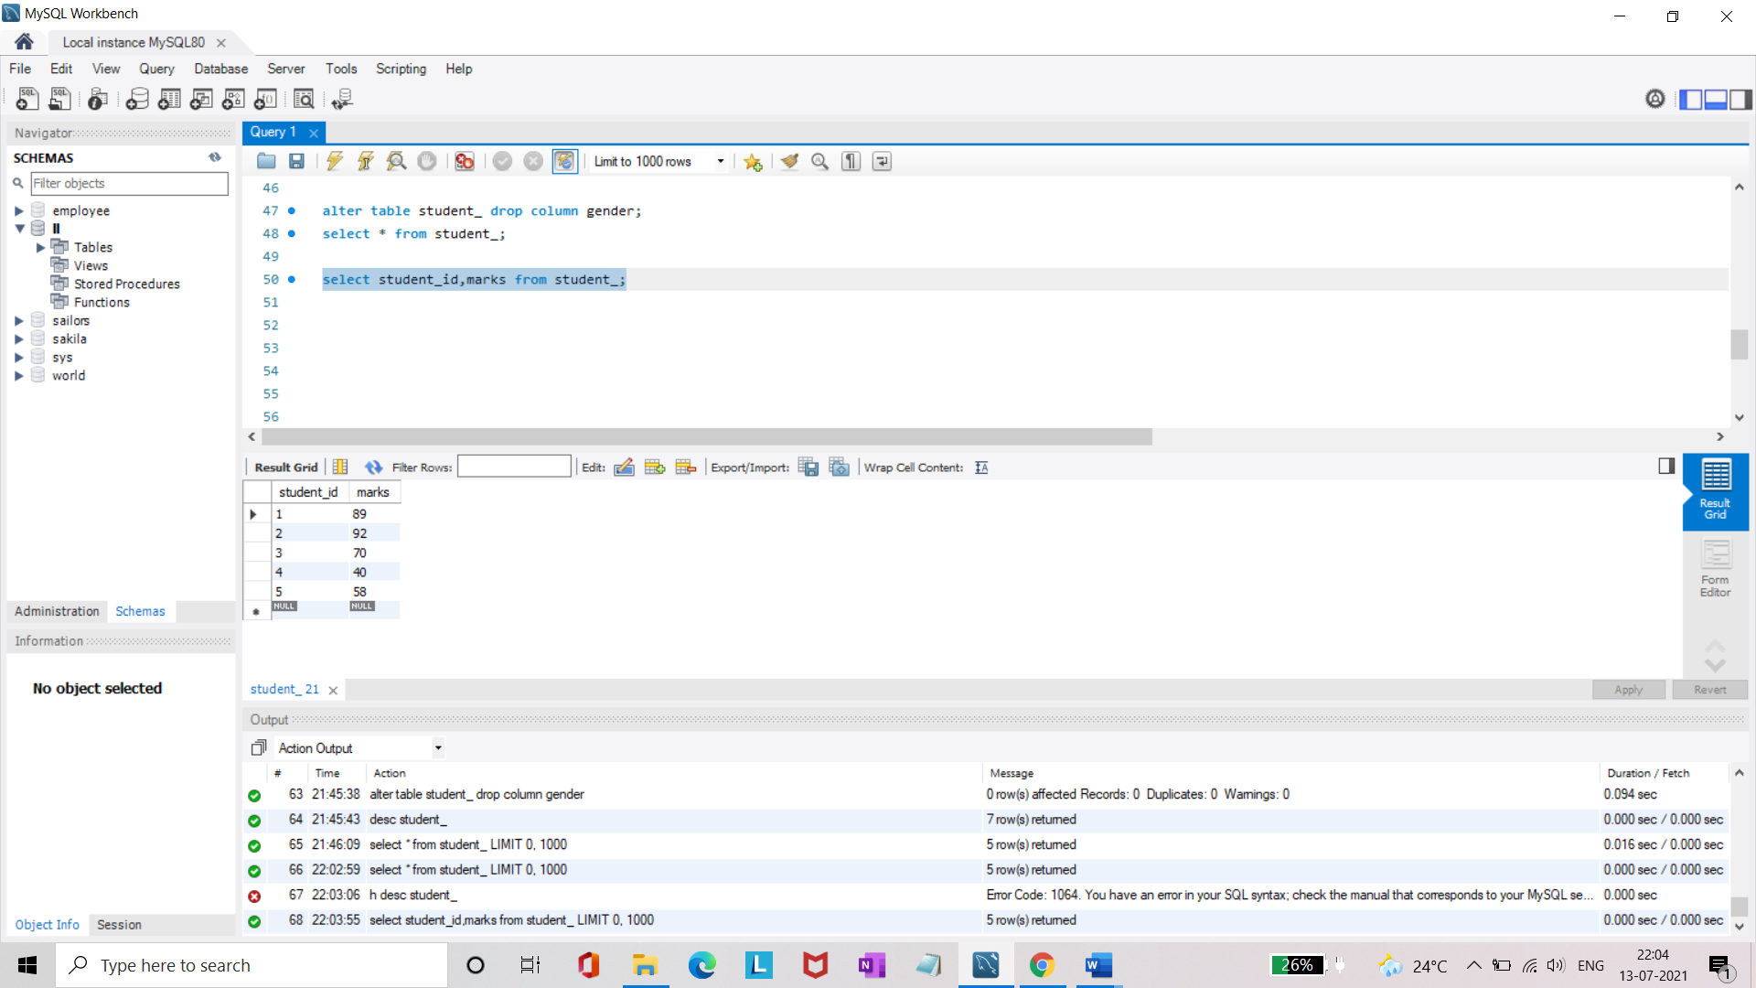

* Display faculty id and name from the faculty table.

**select faculty_id,faculty_name from faculty_;**

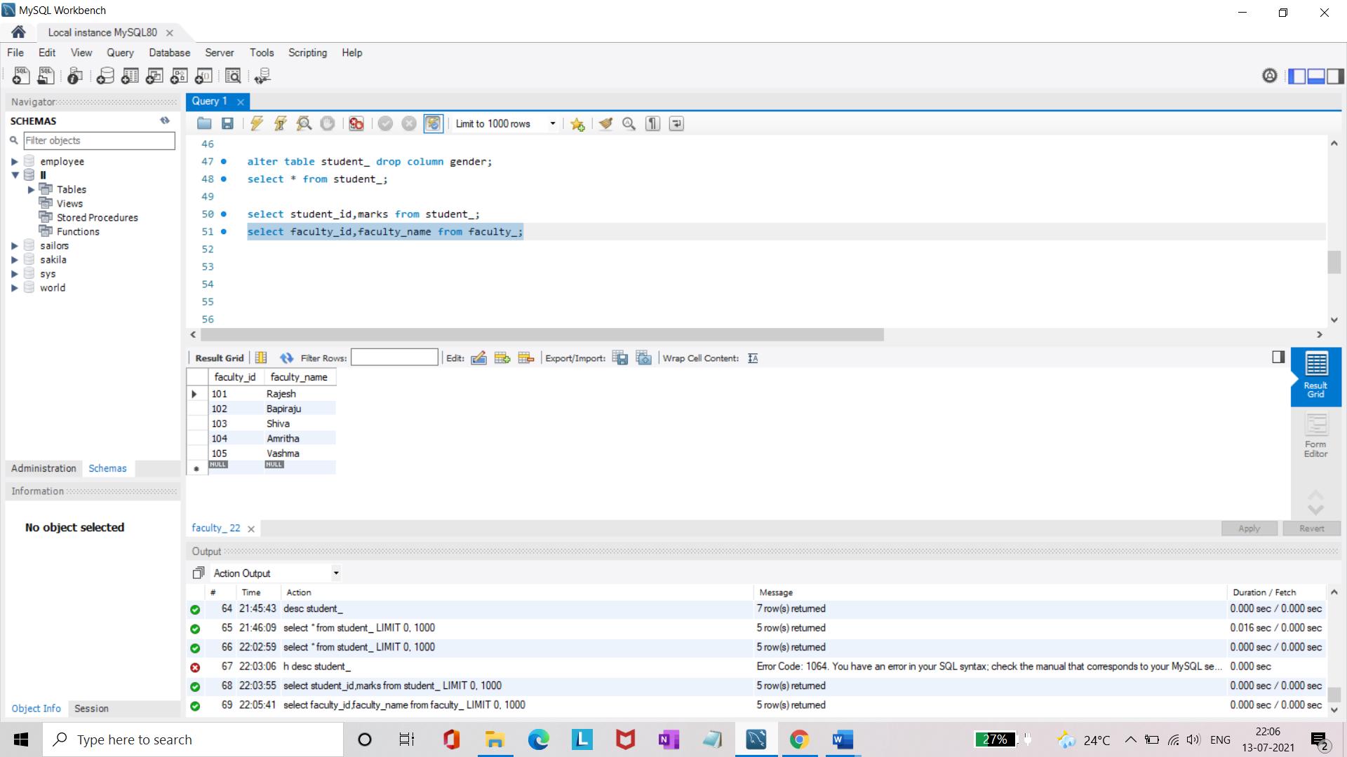

* Display who got grade A.

**select * from student_ where grade='A';**

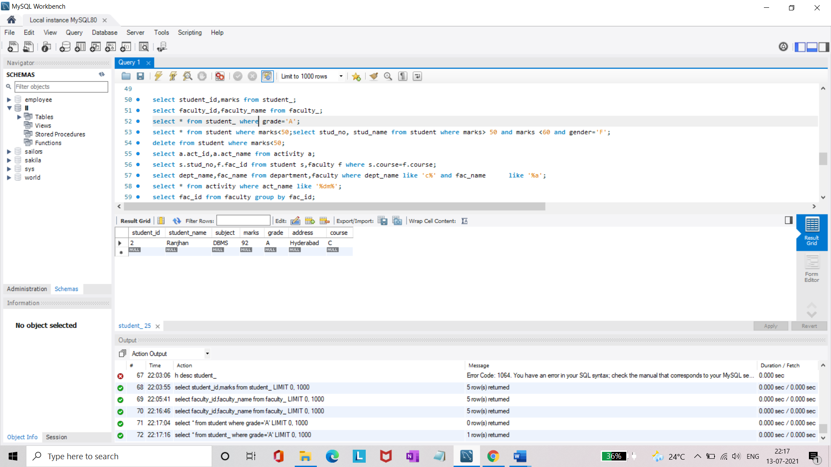

* Display whose marks are less than 50.

**select * from student_ where marks<50;**

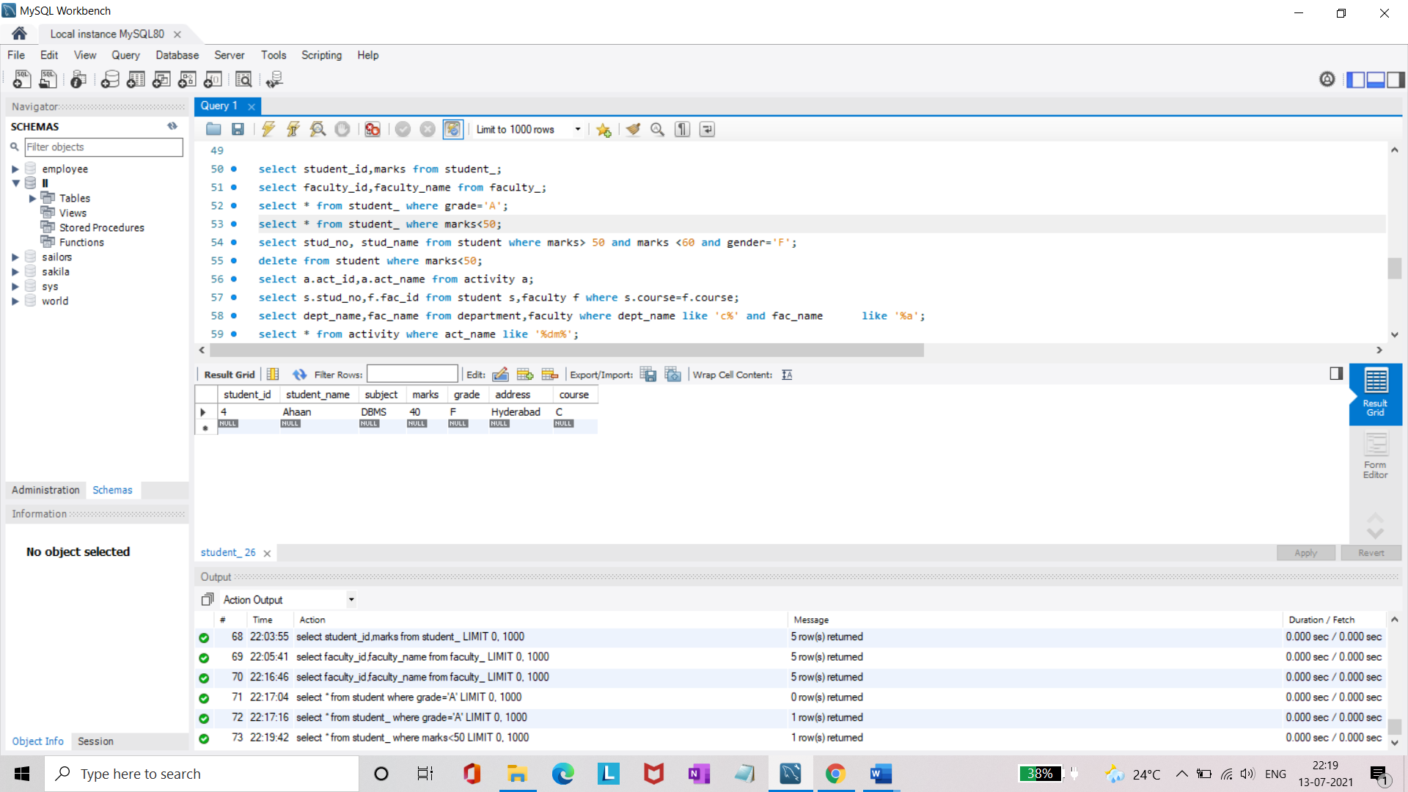

* Display the female students whose marks are between 50 to 60.

**select student_id, student_name from student_ where marks> 50 and marks <60 and gender='Female';**

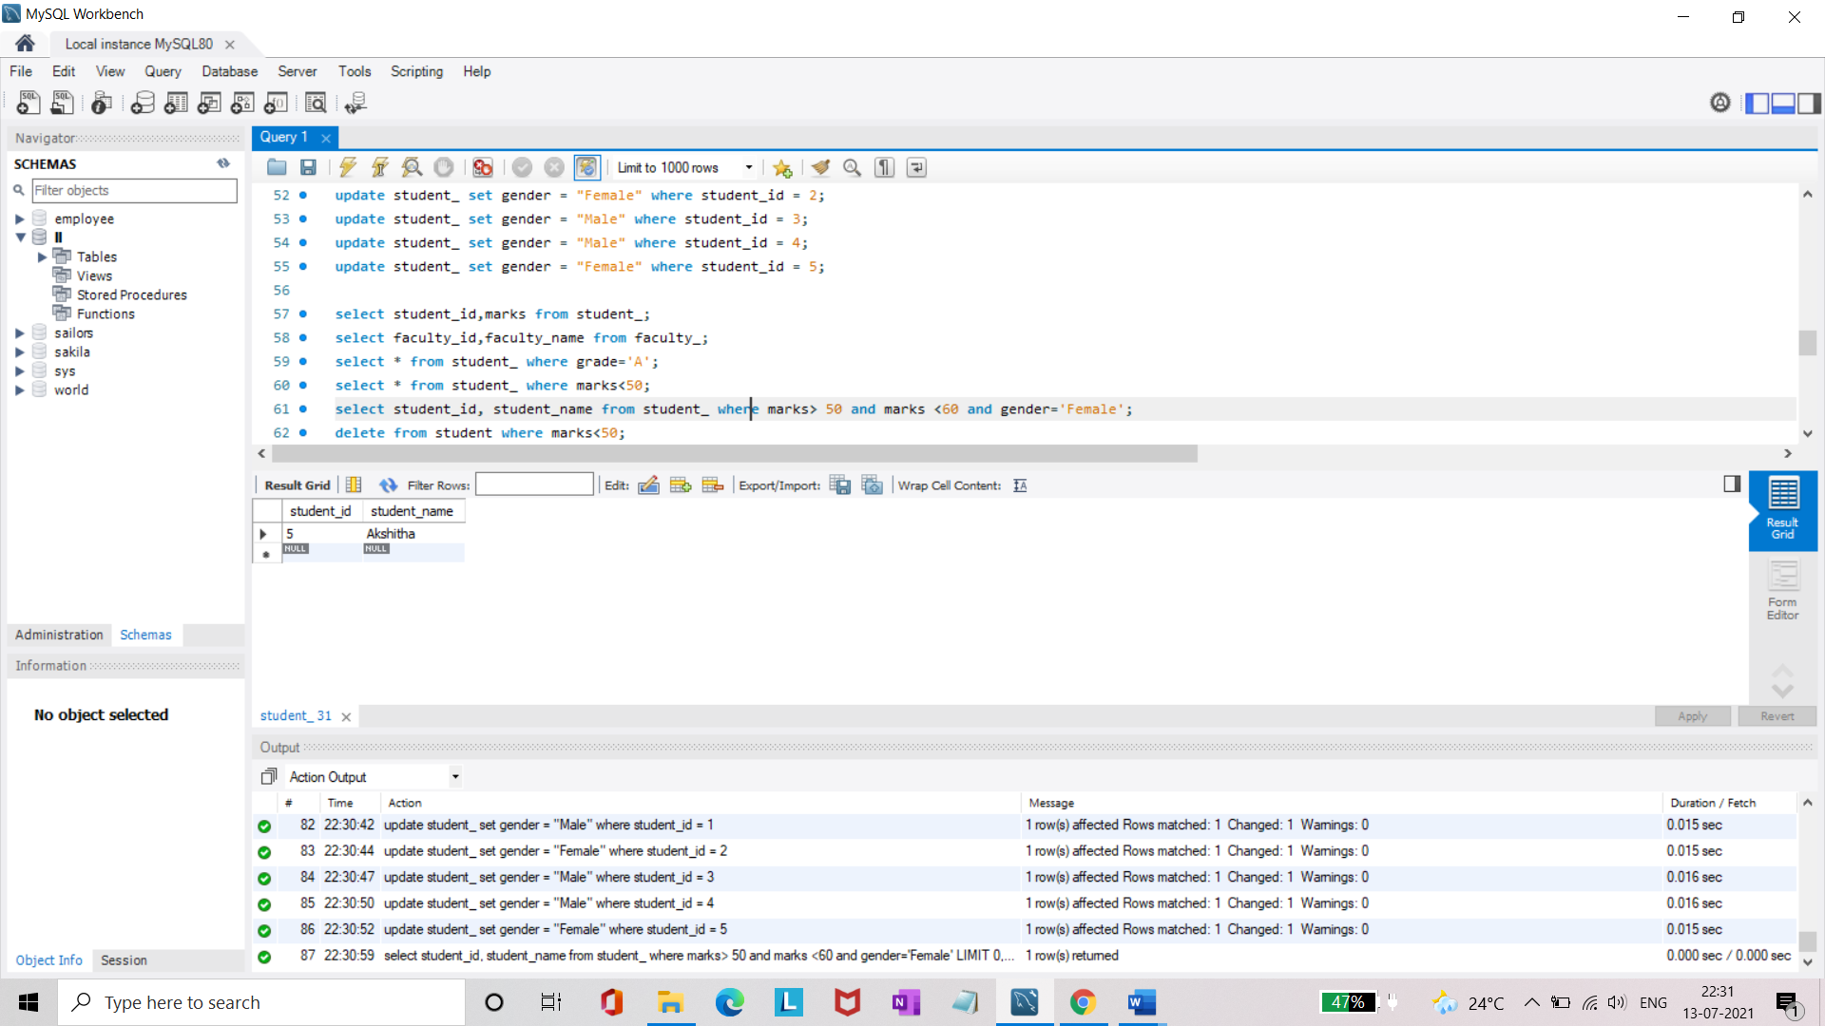

* Delete the failed students.

**delete from student_ where marks < 50;**

**select * from student_;**

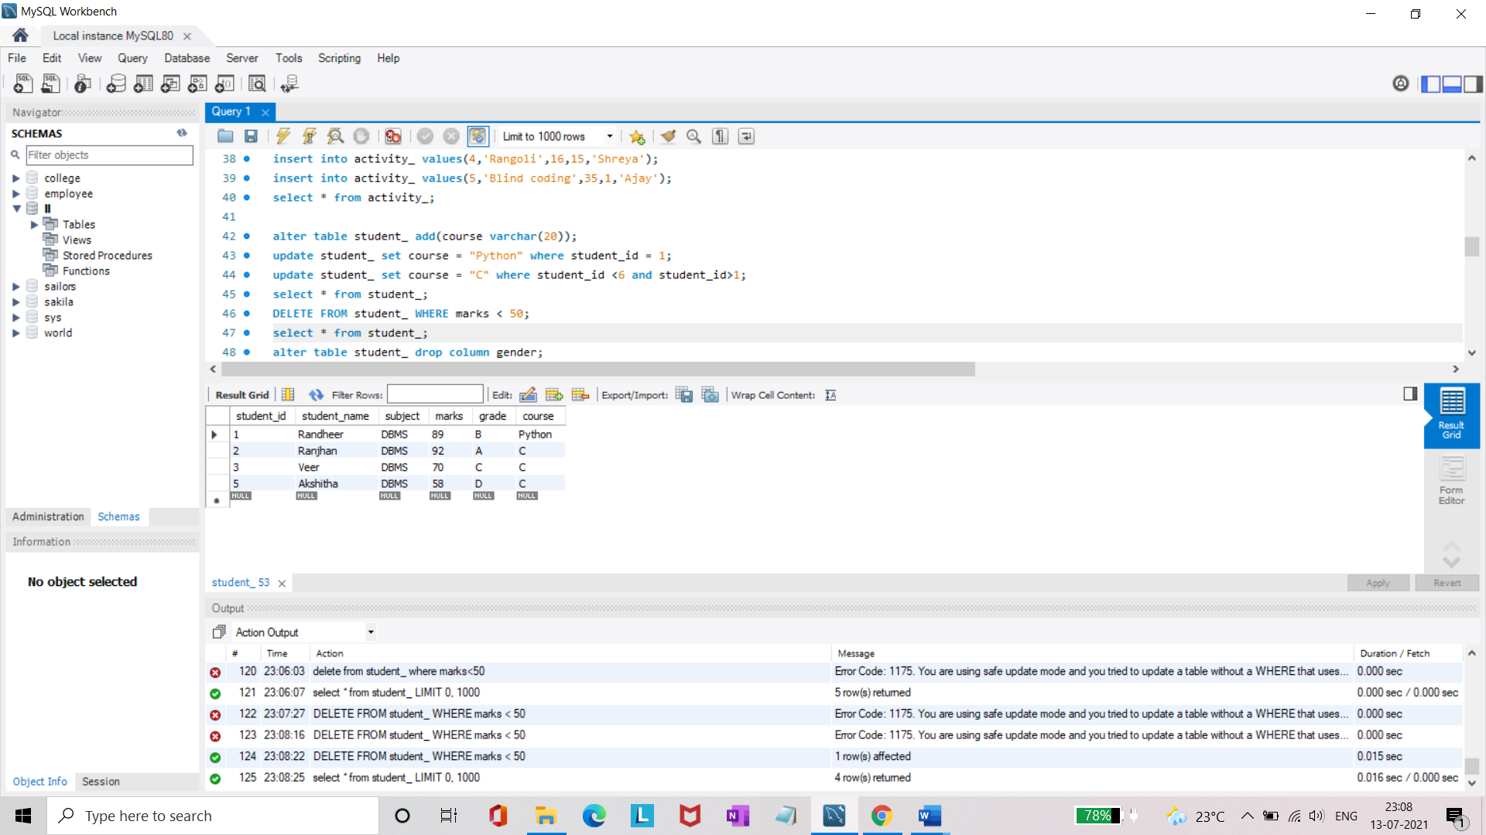

* Display activity id and name using object.

**select a.activity_id,a.activity_name from activity_ a;**

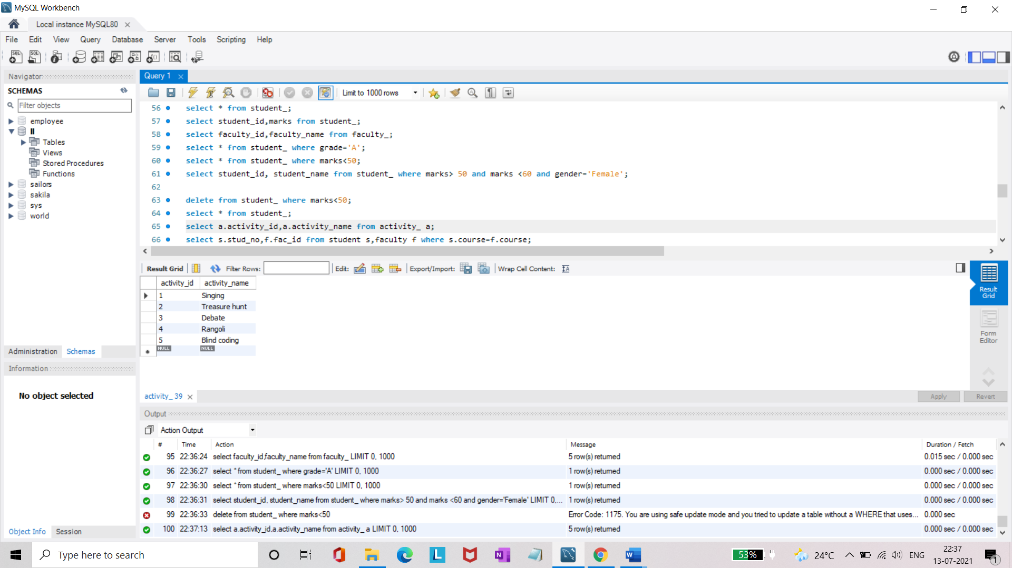

* Display student id, faculty id using course name condition with object.

**select s.student_id,f.faculty_id from student_ s,faculty_ f where s.course=f.course;**

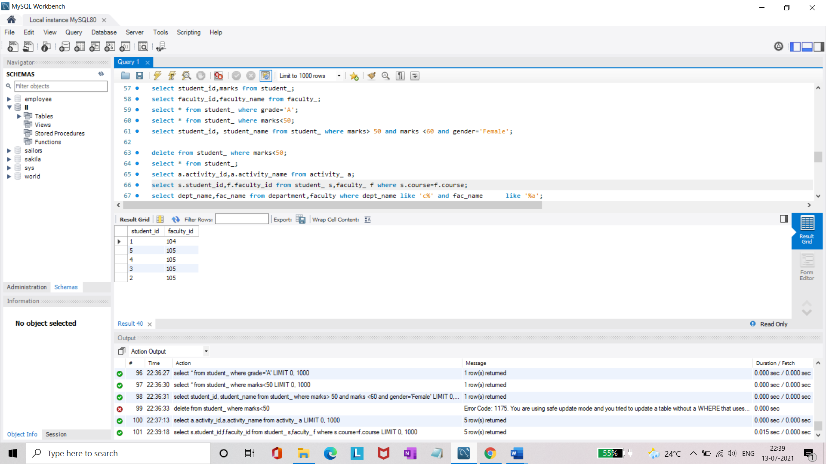

* Select department name starting from ‘c’ and faculty name ending with ‘

’.

**select department_name,faculty_name from department_1,faculty_ where department_name like 'C%' and faculty_name like 'A%';**

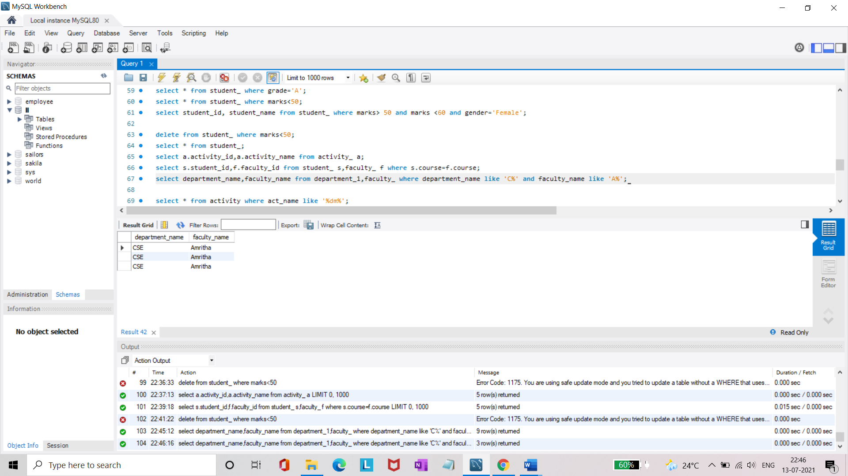

* Select activity having characters between ‘ck’.

**select * from activity_ where activity_name like '%i%';**

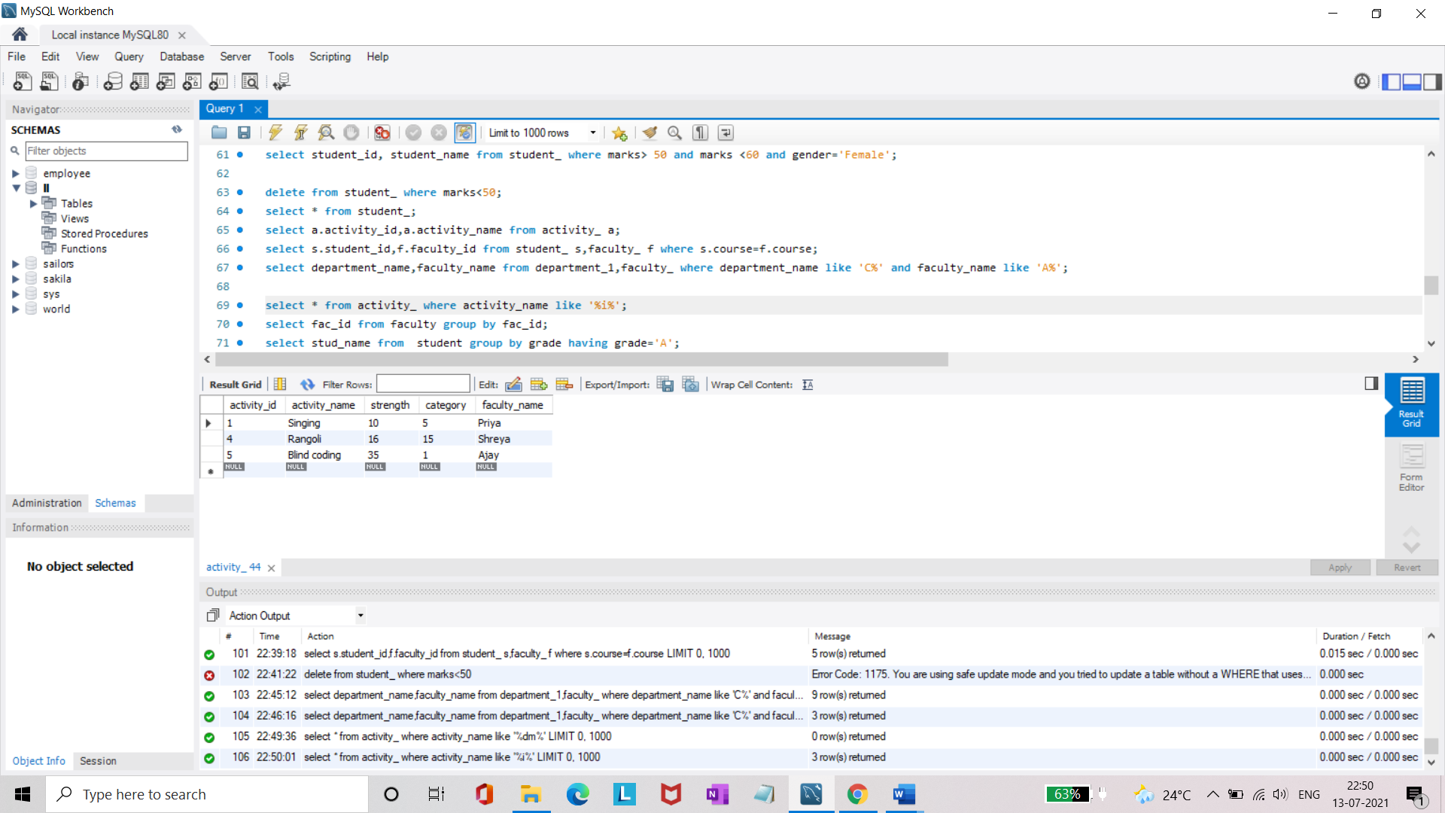

* Group by faculty id and display.

**select faculty_id from faculty_ group by faculty_id;**

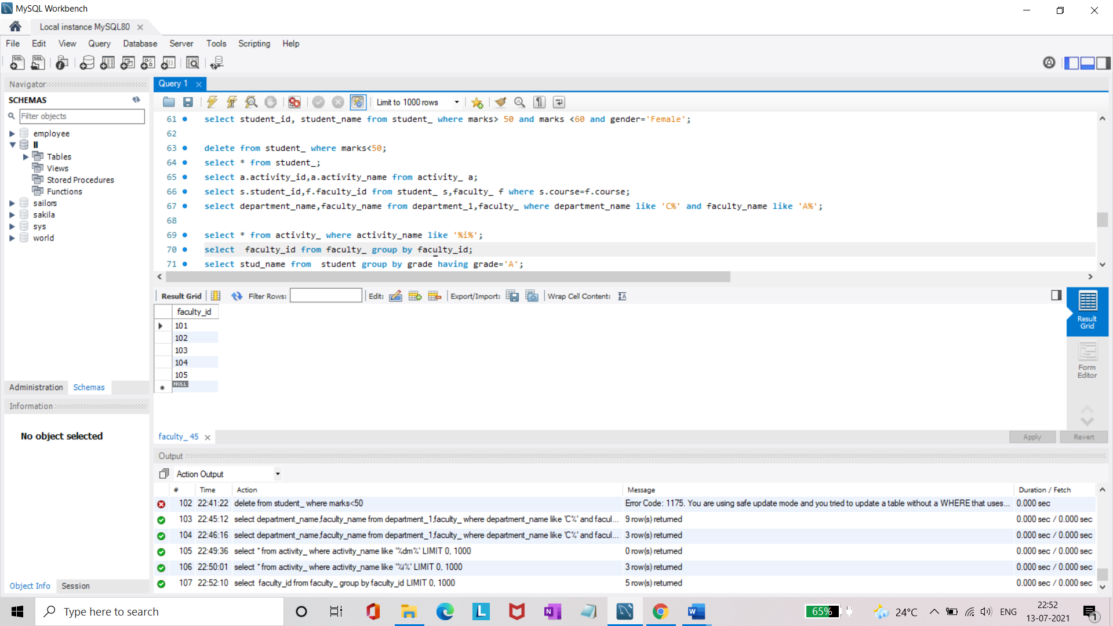

* Display the students list whose grade is A using having.

**select student_name from student_ group by grade having grade='A';**

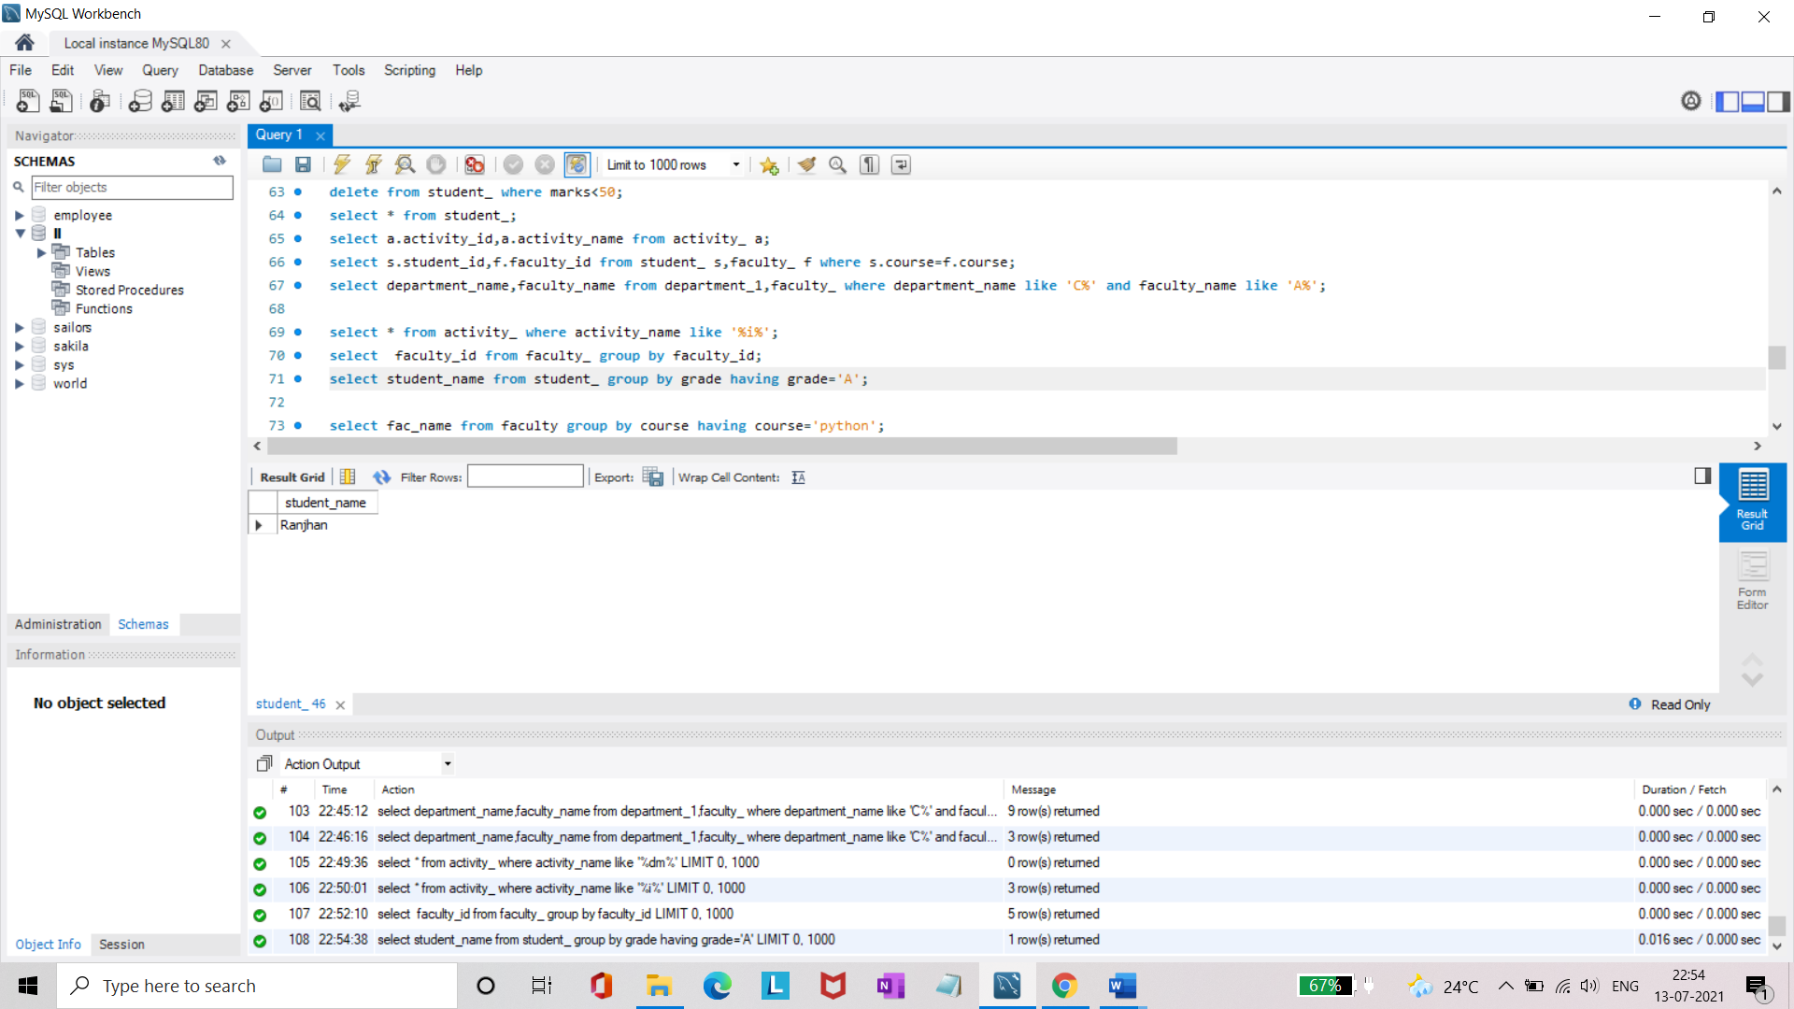

* Display the faculty list who are teaching PPS.

**select faculty_name from faculty_ group by course having course='C';**

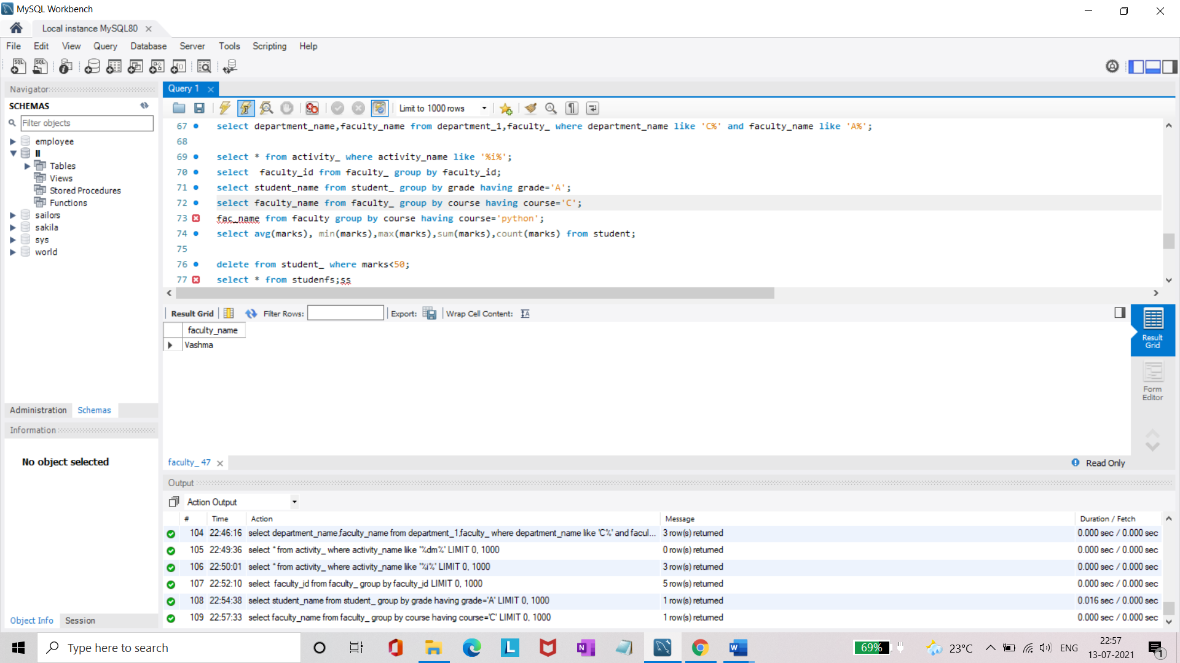

* Apply aggregate functions in student marks - max, min, sum, count, avg.

**select avg(marks), min(marks),max(marks),sum(marks),count(marks) from student_;**

